A picture containing clipart

Description generated with very high confidence

Azure 103 Module 5

Hands On - 1

Azure Certification Training

[**support@intellipaat.com**](mailto:support@intellipaat.com)

**+91-7022374614**

**US: 1-800-216-8930(Toll Free)**

**Azure 103 Module 5 Hands On – 1**

**Create Internal Load Balancer**

**Step 1:** Create three virtual machines within a single availability set and same virtual network and install IIS on two of these three VM using RDP.

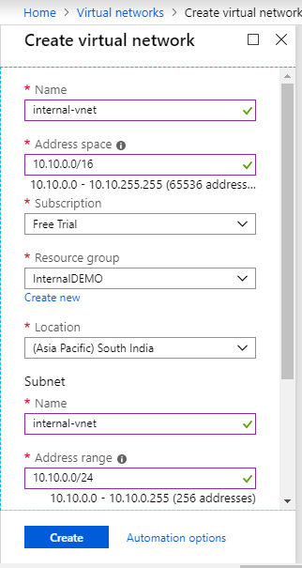

**Step 2:** Search load balancer and click on it.

**Step 3:** Click on ‘+ Add’.

**Step 4:** Add details and click ‘Review + Create’.

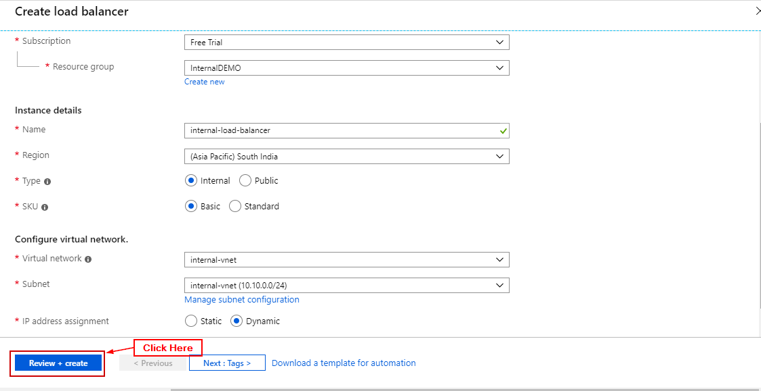

**Step 6:** Click on ‘Create’.

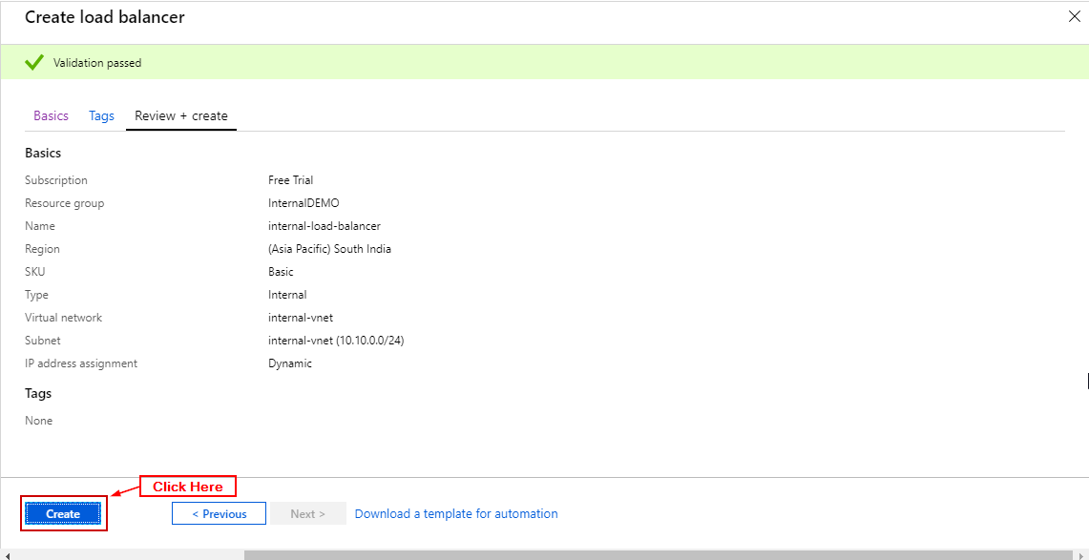

**Step 11:** In load balancer click on backend pools and click on ‘+ Add’.

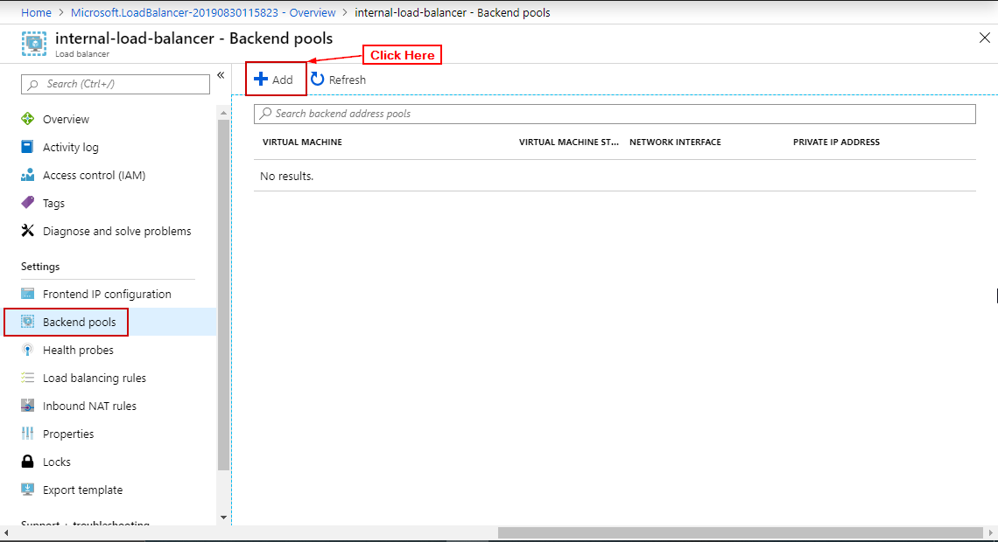

**Step 12:** Enter the details (Availability Set, in target IP Configuration add both VM’s and their IP) and click on OK.

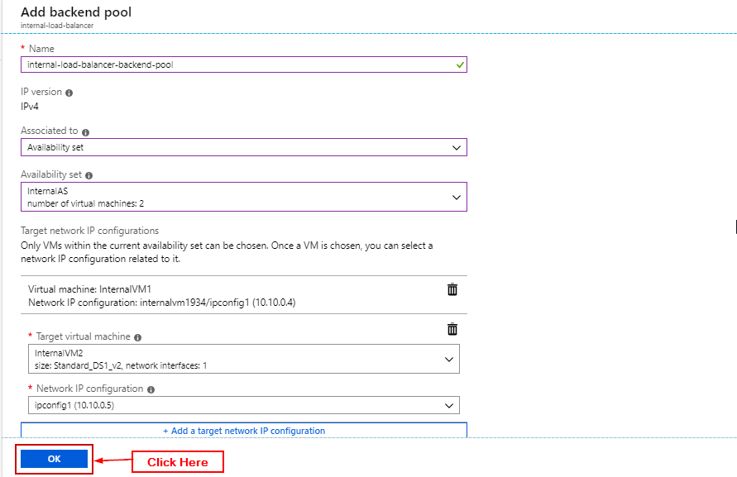

**Step 13:** In load balancer click on health probes and click on ‘+ Add’.

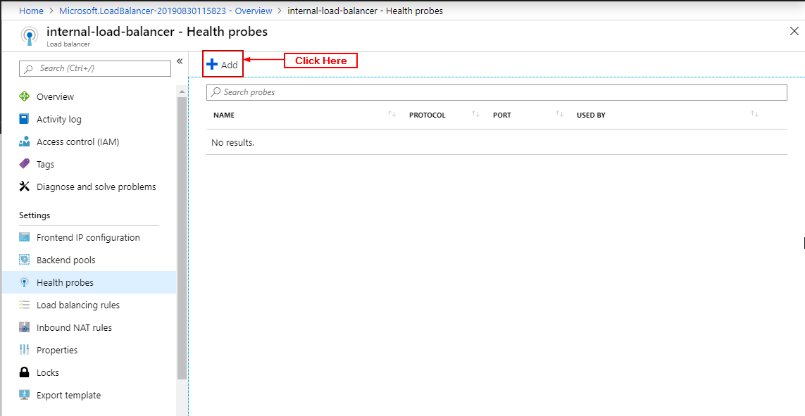

**Step 14:** Enter details click on OK.

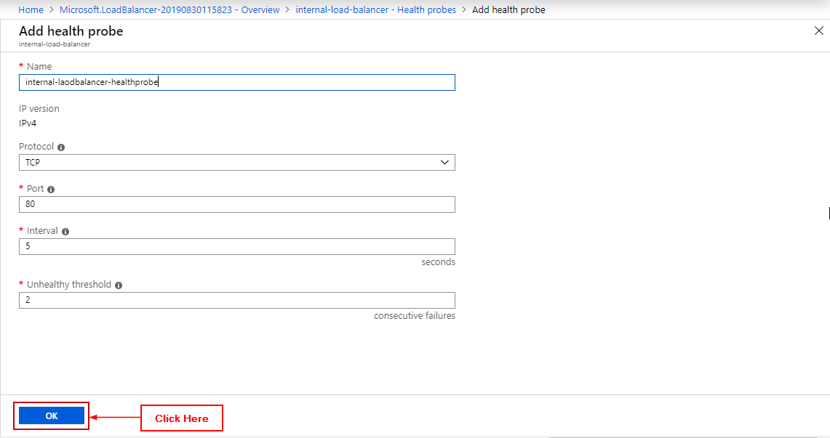

**Step 15:** In load balancer click on Load Balancing Rule and click on ‘+ Add’.

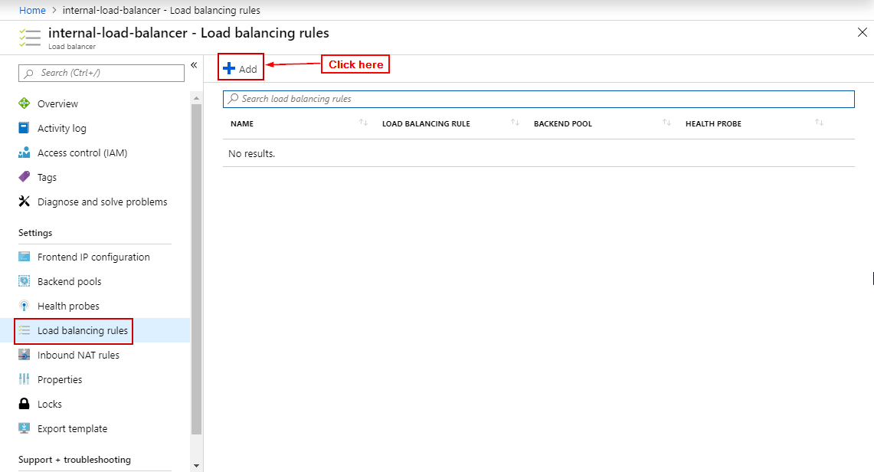

**Step 16:** Enter details click on OK.

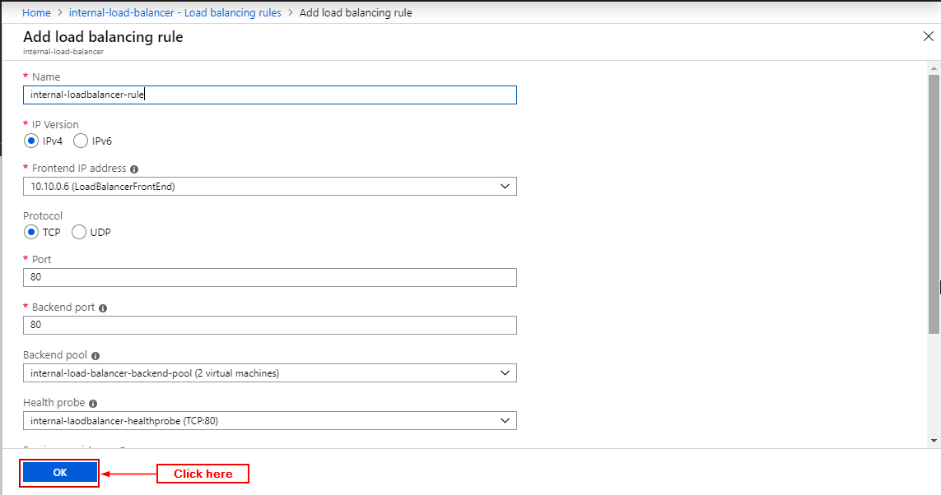

**Step 17:** Open load balancer’s Front End IP Configuration and copy the IP Address.

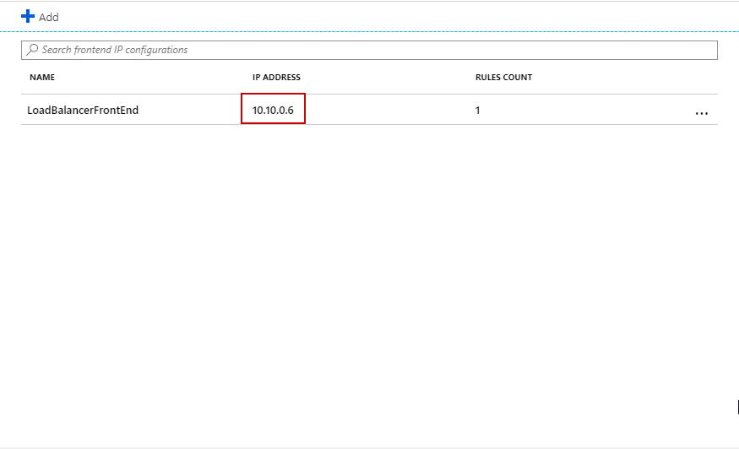

**Step 18:** Open that IP Address in the Third VM you added.

